**BloodyFast**

**DONATE & DISTRIBUTE. FAST.**

**User Manual**

Bloody fast is an application meant to ease the entire process of blood donation, for all its partakers. Here’s what you need to know to get you started:

**Donor**

If you are eager to donate blood, look no further. Our application walks you through all of the steps, you simply need to create an account through our registration page by entering the required information.

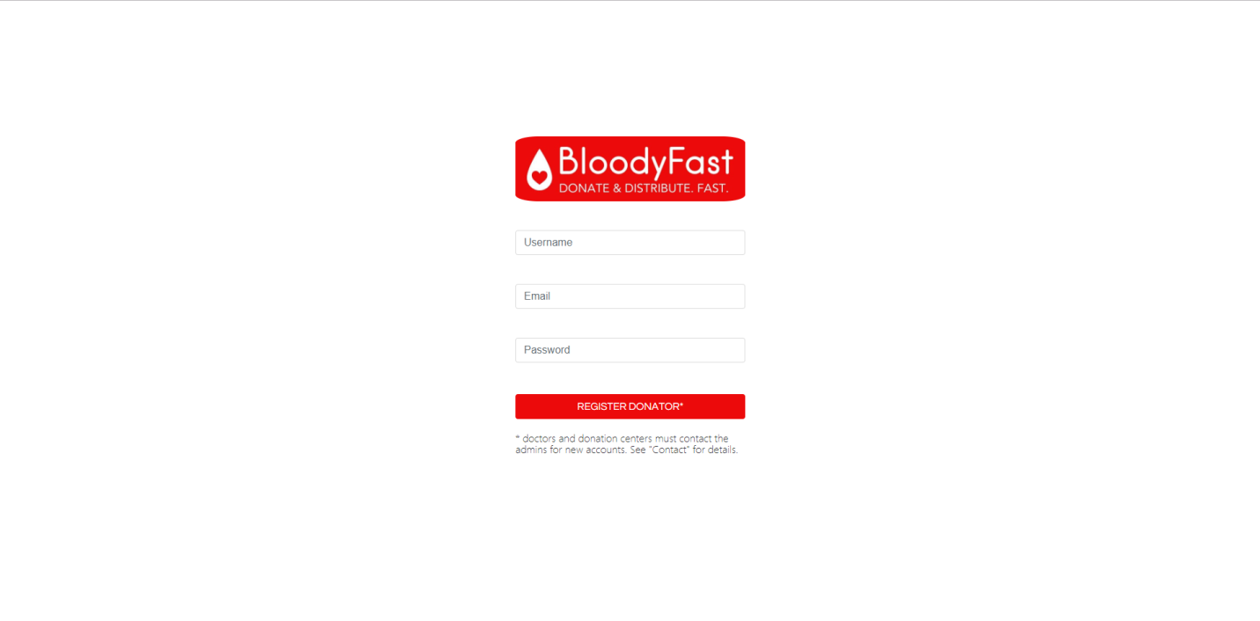

Already have an account? Enter your credentials and log in to find your very own user dashboard where you can see your current test and donation situation (test results and upcoming possible donation date).

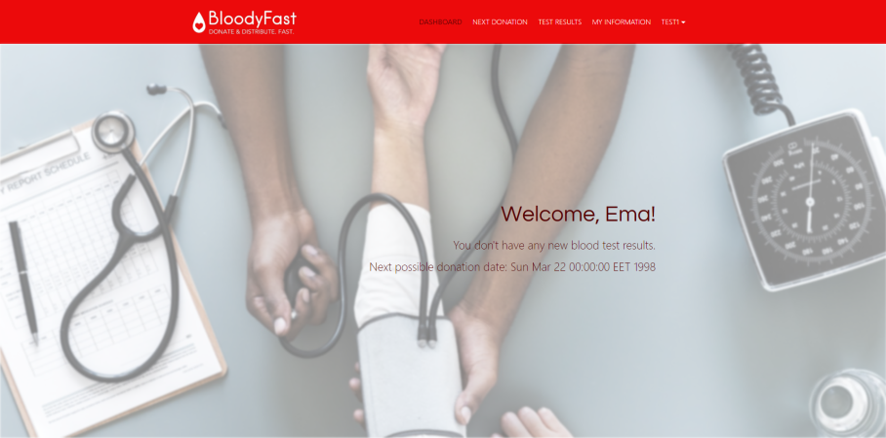

If you are new, however, we kindly ask you to fill in some personal information in order for us to improve the efficiency of your future donations. Do this by clicking on the My Information section in the navigation bar and inserting the required information.

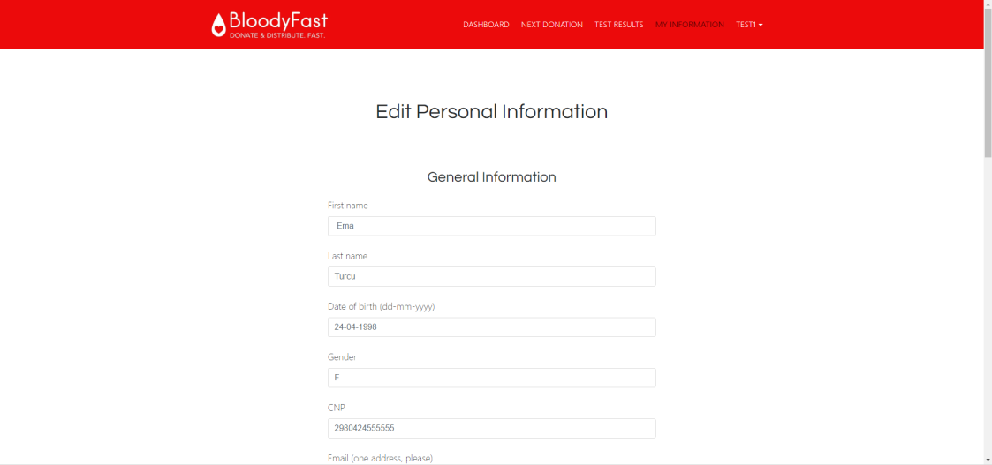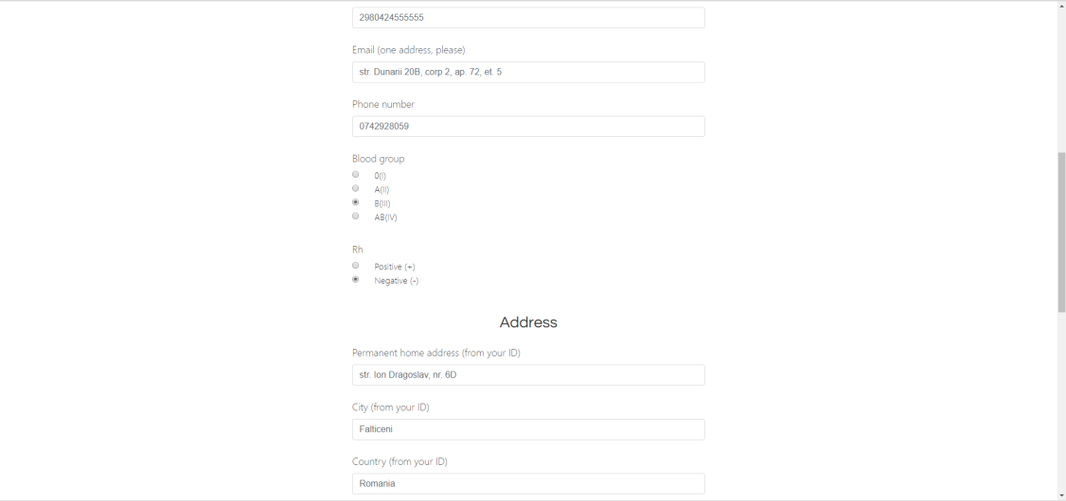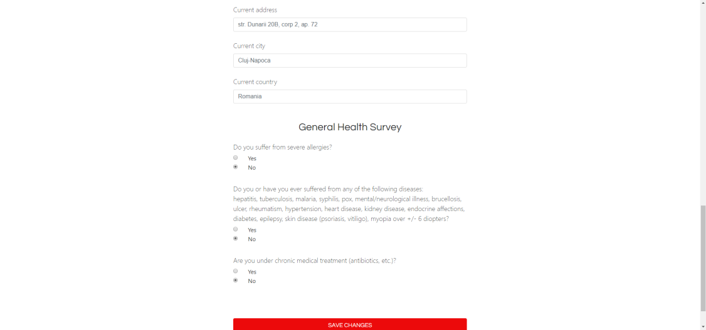

After this step you are free to fill in a donation form, if you are willing to donate blood. Do this by clicking the Next Donation tab, that will redirect you to the donation form page where you can fill some critical fields that will determine whether you are suitable to donate blood or not.

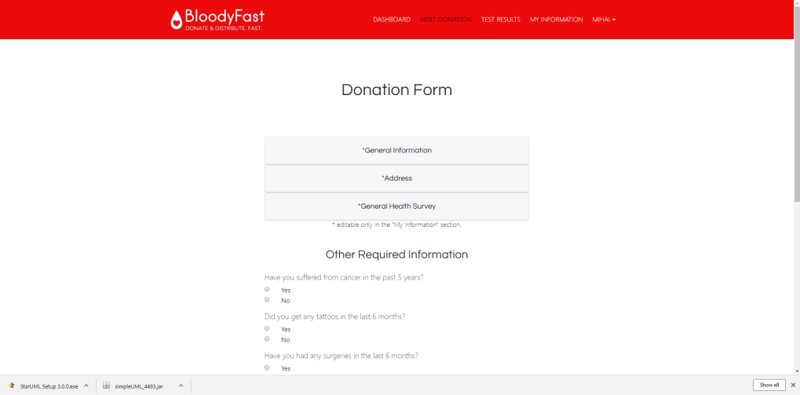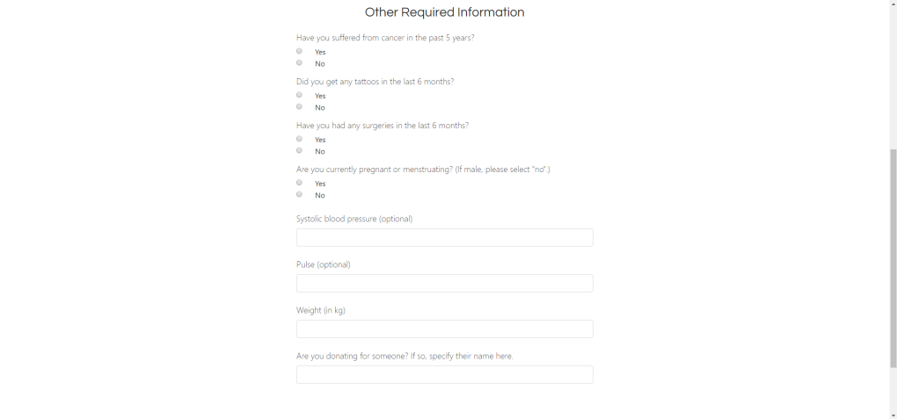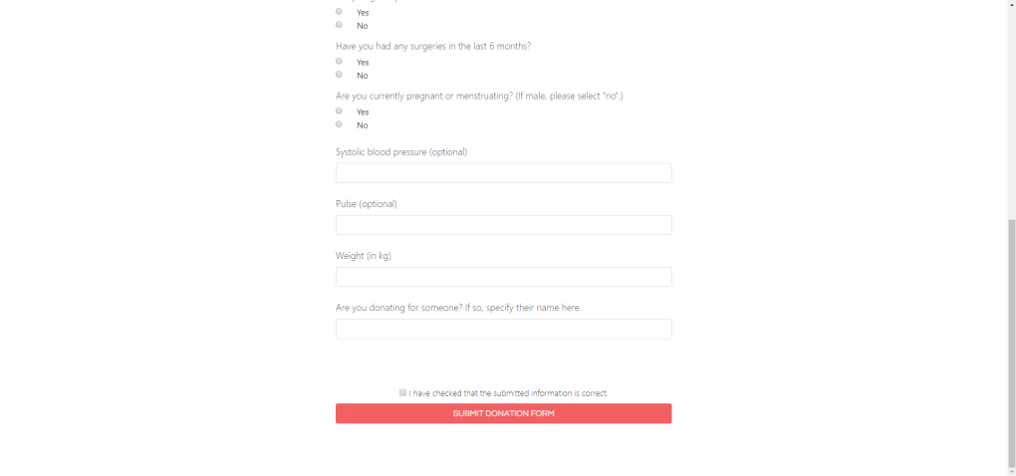

Once ready, the results can be accessed in your Test Results tab.

**Doctor & Bank Staff**

Official personnel involved in the process of donation do not have to create their own accounts as they are created for them by an admin.

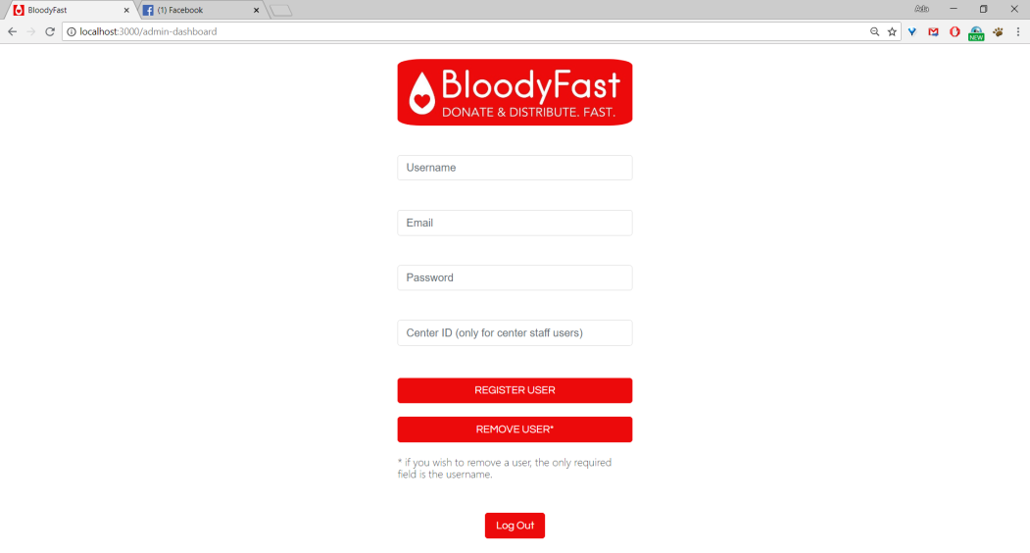

On the other hand, you are able to interact with one another in order to reach the best possible outcomes when it comes to blood donation.

As a doctor you can click the New Request tab based on your needs for a specific type and quantity of blood; these requests can be managed through the My Requests page.

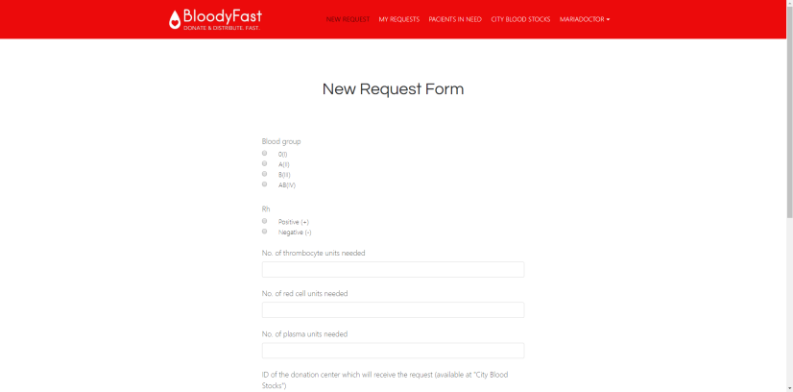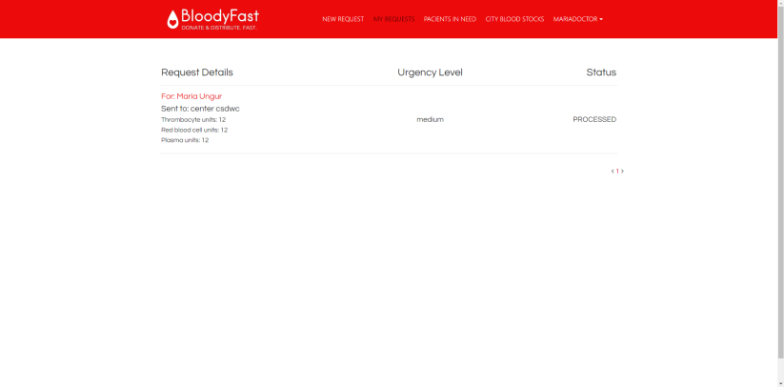

If you are part of the blood bank staff, you can manage the requests submitted by the doctors through the Requests tab, and supply them with the required blood, based on their needs and the blood’s availability. You can check that in the Stock section of your page, you can also see if the blood is usable, and discard it otherwise, or, if there has been a recent donation, add it to the stock.

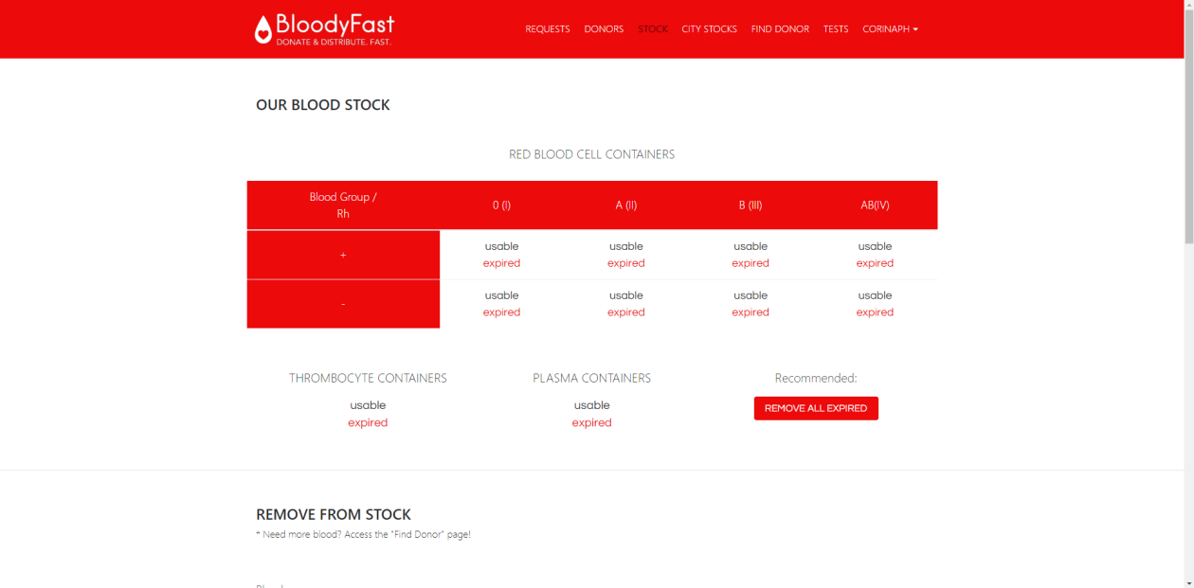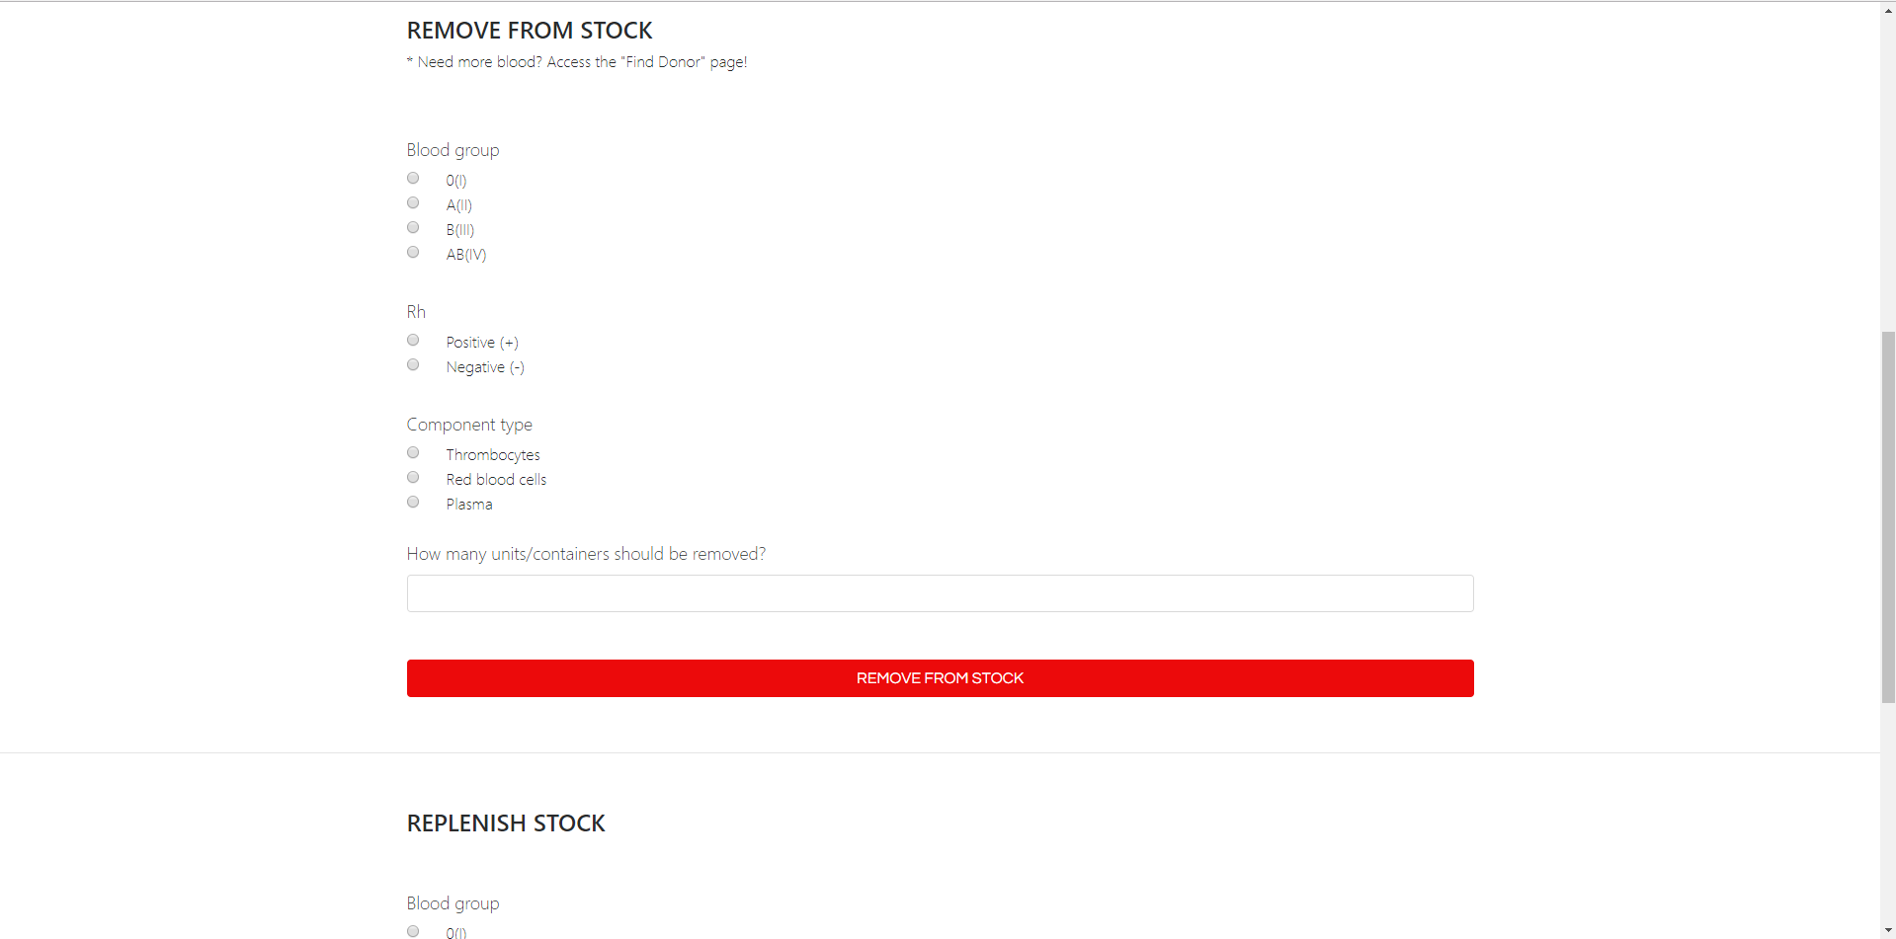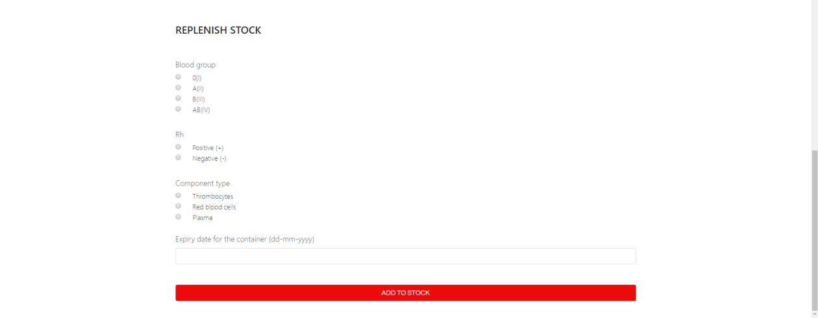

Furthermore, if a certain resource is unavailable, click the Find Donor button in your navigation bar in order to find the nearest registered donor that matches your needs.

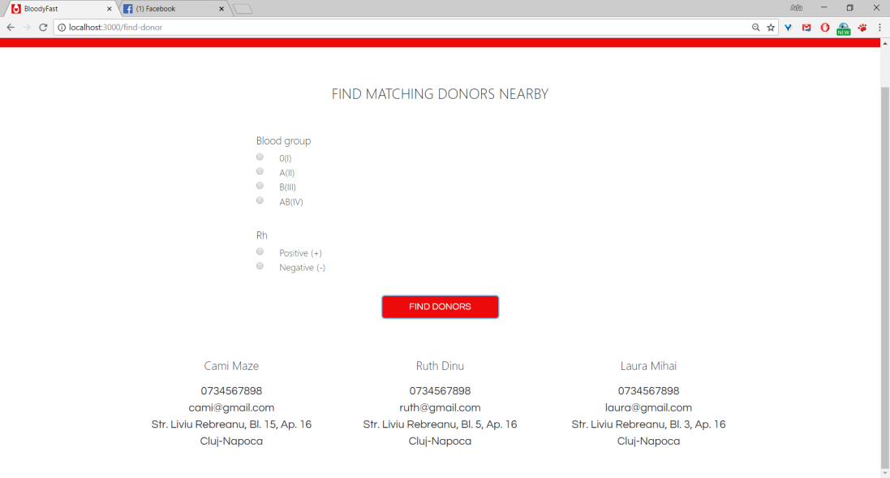

Lastly, as a member of the blood bank personnel, it is your responsibility to manage the results of donors’ blood tests, and that is available via the Tests page, where you can upload a patients’ results (either by selecting the files or via drag-and-drop from your computer), and they will be notified of them.

